MED D - SilverScript - Resolution of Eligibility

General Information
Search for the Beneficiary’s Eligibility
Senior Team
Troubleshooting
Related Documents

Description: This document provides the process for verifying the beneficiary’s eligibility.

General Information
When a beneficiary contacts Customer Care for any issue, the Med D Customer Care Representative (CCR) should always verify the beneficiary’s eligibility and determine the correct designated team to address the caller’s request.

Occasionally when attempting to locate the beneficiary’s account, the CCR will have difficulty in locating the account.

BEFORE telling the beneficiary they are NOT eligible, the CCR should utilize ALL of their resources in researching the beneficiary’s eligibility.
- PeopleSafe
- FAZAL
- Marx
- The Senior Team (RxClaim access)

Note: If a Benefits Office is calling to update a beneficiary’s eligibility, transfer to the Senior Team. Refer to MED D - When to Transfer Calls to the Senior Team.

Additionally, CCRs may receive inquiries from a beneficiary with more than one type of benefit plan. This is referred to as Single Transaction Coordination of Benefits (STCOB).

The CCR should utilize the CIF to determine if the beneficiary is a part of an STCOB EGWP client, and the MED D - Single Transaction Coordination of Benefits (STCOB) Tips and Reminders job aid to research claims in PeopleSafe.
- Refer to the Troubleshooting section of this document.

The CCR should be diligent in their research to try and assist the beneficiary. However, there will be instances when the call will need to be transferred to the designated care team or Senior Team. Refer to MED D - When to Transfer Calls to the Senior Team.

Top of the Document

Search for the Beneficiary’s Eligibility
When searching for a beneficiary’s eligibility, the CCR may have to search through multiple systems to find details on the beneficiary. The diagram below represents the path the CCR would follow to search, navigating from one system to the next until a result is found.

PeopleSafe  Search in PeopleSafe | RxClaim  Search RxClaim in PeopleSafe | Medicare D Inquiry tab  Search in Medicare D Inquiry tab | FAZAL  Search in FAZAL | MARx  Search in MARx

In order to begin the process for verifying the beneficiary’s eligibility, the CCR will always begin in PeopleSafe and perform the following steps:

Step | Action
1 | Search in PeopleSafe for an active line of eligibility for the beneficiary’s account.  - Refer to the Member Search - Finding a Member in PeopleSafe work instruction.  Result: If an active line of eligibility is located/selected, the Main screen will display.
1 | If… | Then…
1 | Eligibility found for the beneficiary | - Proceed with answering the beneficiary’s questions.  - If applicable transfer the beneficiary to the designated care team to address their issue.
1 | Future Eligibility found | Advise the beneficiary that their eligibility has been found on file, but that it has a future effective date of MM/DD/YYYY.  DO NOT TELL THE BENEFICIARY THEY ARE NOT ELIGIBLE!  Answer any drug coverage inquiries.  Refer to the following work instruction:  - MED D - Test Claim  - If applicable transfer the beneficiary to the designated care team to address their issue.
1 | No Eligibility record found for beneficiary | DO NOT TELL THE BENEFICIARY THEY ARE NOT ELIGIBLE!  Proceed to Step 2.
1 | No active Eligibility record found for beneficiary for a specified client | DO NOT TELL THE BENEFICIARY THEY ARE NOT ELIGIBLE!  Refer to the Eligibility section of the CIF.  If no specific client process is listed in the CIF, proceed to Step 2.
1 | Red text displays in the lower section of screen when searching for a beneficiary | Search returns error: DO NOT READ TO THE MEMBER.  This is CCR information only.  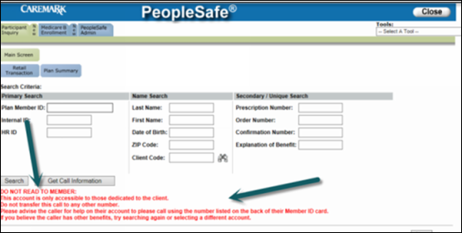  I apologize but your benefits are not serviced by us. Please call the Customer Care number listed on the back of your ID card.  Note: If the beneficiary does not have an ID Card, advise them to contact their medical carrier or Human Resources department.  Do not transfer these calls or attempt to further help the caller.
2 | - Click the Search RxClaim button.  Note: When no search results are found, a new Search RxClaim button will display to the right of the Search button.  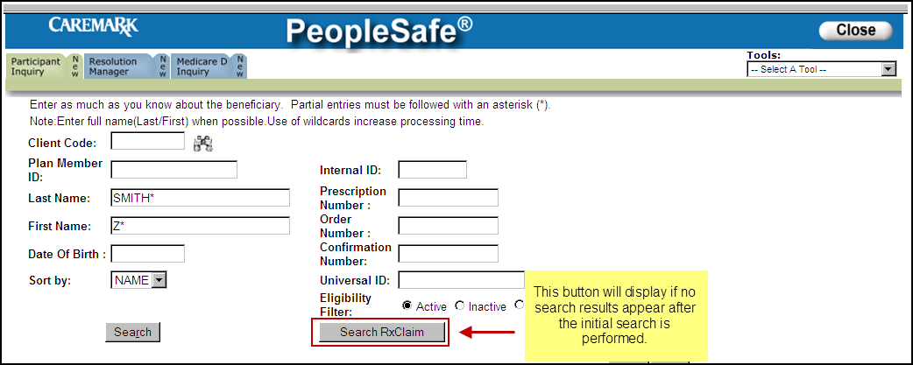  - Choose the active line of eligibility and click the Select button.  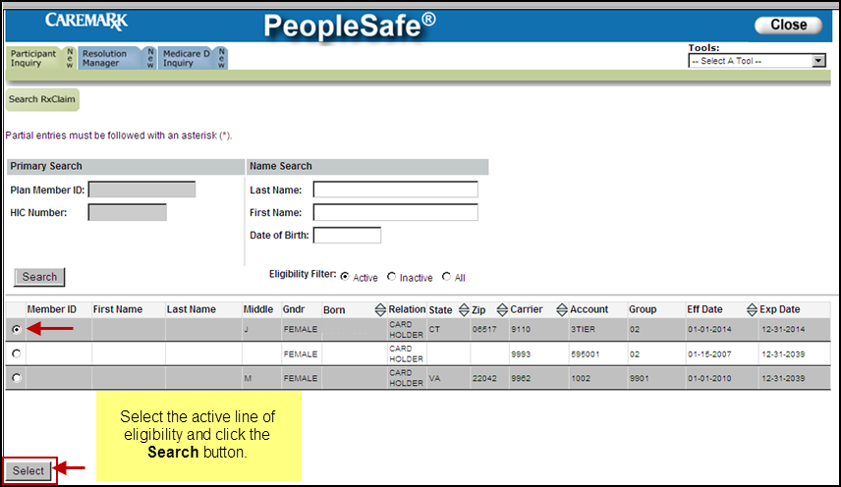  Result: The RxClaim Participant Details screen will display.  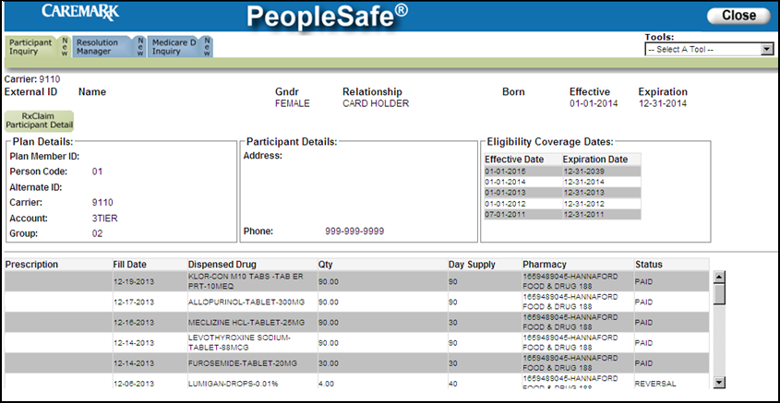  Note: When the CCR is able to locate eligibility information using the Search RxClaim functionality, the beneficiary has active prescription benefits, but their profile has not fully loaded into all systems.  - As long as the beneficiary is active in RxClaim, they can utilize their benefits at the local pharmacy to obtain medication.  - The beneficiary’s full profile must be loaded into all systems before they can utilize mail order prescription services.
2 | If the CCR does … | Then…
2 | Find active eligibility for the beneficiary in RxClaim | Assist the beneficiary in obtaining any medications locally.  - Refer to the Retail Logic section of the CIF if necessary.
2 | NOT find active eligibility in RxClaim | DO NOT TELL THE BENEFICIARY THEY ARE NOT ELIGIBLE!  Proceed to the next step.
3 | Under the Medicare D Inquiry tab, locate the beneficiary by performing a MBI/HIC Number search.  - CCR Process Note: Although other search methods are available, only search for the beneficiary using their MBI.  - Exception: Offshore Vendors will select New next to Participant Inquiry Tab to search for the beneficiary. Once beneficiary is located, navigate to the Medicare D Inquiry Tab.  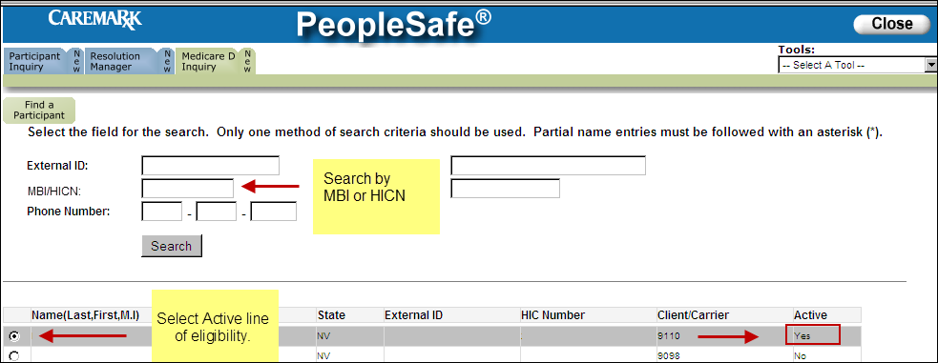
3 | If is the beneficiary’s eligibility is… |  | Then…
3 | Found |  | - Select the Active line of eligibility.  - Click the Select button.  - Click on the Plan Details screen.  - The following pieces of information can be found on the Plan Details screen:  - Benefit Effective date  - Benefit Expiration date  - Plan Type (Account field)  - Low Income Subsidy (LICS or LIPS) level information  - MED D Premium and Late Enrollment Penalty (Participant Penalty) information  Note: Information will display on the Plan Details screen only if SilverScript handles the client’s eligibility.  - If an active line of eligibility has been found under the MED D Inquiry tab, the beneficiary has active prescription benefits, but their profile has not fully loaded into all systems.  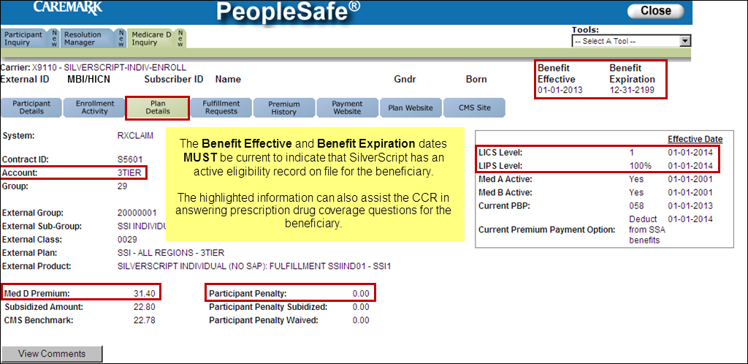  If the beneficiary has plan design questions, refer to the following documents:  - For SilverScript beneficiaries:  - MED D – 2023 SilverScript PDP Readiness Plan Design Reference  - MED D - Drug Pricing Tool  - For EGWP beneficiaries:  - The appropriate client’s CIF  Proceed to Step 6.
3 | NOT found |  | The following screen will display if no eligibility is found under the MED D Inquiry tab in PeopleSafe.  DO NOT TELL THE BENEFICIARY THEY ARE NOT ELIGIBLE!  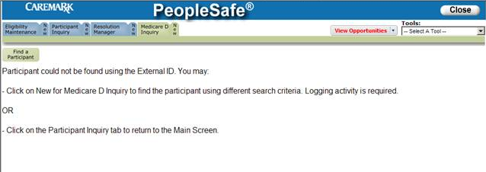  Refer to the Eligibility section of the CIF.  CCR Process Note: If no specific client process is listed in the CIF, proceed to the next step.
4 | Attempt to locate the beneficiary in FAZAL.  - Refer to the MED D Enrollment - FAZAL work instruction.  CCR Process Note:  Search for the beneficiary via:  - Name  - DOB  - MBI  Note: If the CCR does not have access to FAZAL, they will warm transfer the call to the Specialized Member Services Team (SMST). Refer to MED D - Guide to Transferring a Call.  - Check the Enrollment Portal for a completed enrollment.
4 | If the beneficiary is… | Then the CCR will…
4 | Found in FAZAL | Verify if the enrollment is complete.  Note: Any issues which may have held up the beneficiary’s enrollment will show in FAZAL as highlighted in PINK.
4 | Found in FAZAL | If the enrollment is… |  | Then…
4 | Found in FAZAL | Complete |  | Proceed to the next step.
4 | Found in FAZAL | NOT complete |  | Refer to the MED D Enrollment - Incomplete Enrollments (ICE) or Enrollments with Missing Information work instruction.  Stop: If the beneficiary says they do not have medications or need medications right away or otherwise is escalating due to their enrollment not being in the system, immediately warm transfer the call to the Specialized Member Services Team (SMST). Refer to MED D - Guide to Transferring a Call  Proceed to Step 6.
4 | NOT Found in FAZAL | Proceed to Step 5.
5 | Attempt to locate the beneficiary in MARx.
5 | If the beneficiary is… | Then…
5 | Found in MARx with an enrollment in SilverScript | How many days’ supply do you have on hand?
5 | Found in MARx with an enrollment in SilverScript | If the beneficiary has… |  |  | Then…
5 | Found in MARx with an enrollment in SilverScript | 5-day supply or greater on hand |  |  | Submit an RM Task in PeopleSafe:  Task Category: Med D Enrollment - Enrollment  Task Type: Enrollment Not Found  Queue: Med D Enrollment Task  Notes: Include the following:  - Document that enrollment was found in MARx  - Beneficiary Name  - DOB  - MBI  - Contact Number  Refer to the MED D - SilverScript and Blue MedicareRx (NEJE) - Enrollment Related RM Tasks.  Stop: If the beneficiary says they do not have medications or need medications right away or otherwise is escalating due to their enrollment not being in the system, immediately transfer to the Senior Team.  - Refer to the MED D - When to Transfer Calls to the Senior Team.  Proceed to Step 6.
5 | Found in MARx with an enrollment in SilverScript | Less than a 5-day supply on hand  Qualifies as an URGENT Issue |  |  | Submit an RM Task in PeopleSafe and mark as URGENT:  Task Category: Med D Enrollment - Enrollment  Task Type: Enrollment Not Found  Queue: Med D Enrollment Task  Notes: Include the following:  - Document that enrollment was found in MARx.  - Beneficiary Name  - DOB  - MBI  - Contact Number  Refer to the MED D - SilverScript and Blue MedicareRx (NEJE) - Enrollment Related RM Tasks.  Stop: If the beneficiary says they do not have medications or need medications right away or otherwise is escalating due to their enrollment not being in the system, immediately transfer to the Senior Team.  - Refer to MED D - When to Transfer Calls to the Senior Team.  Proceed to Step 6.
5 | Found in MARx with an enrollment in another plan | If a Non-SilverScript (S5601) Contract ID is displayed, advise the beneficiary:  - I see that you are enrolled in another plan starting on <date>. You may contact Medicare about information on that specific plan.  - If you would like to contact Medicare, you can call:  1-800-MEDICARE (1-800-633-4227), 24 hours a day, 7 days a week  TTY users call: 1-877-486-2048  Instruct the beneficiary to ask for an Enrollment agent.  Note: If the caller agrees, cold Transfer him/her to Medicare.
5 | NOT found in MARx with an enrollment in any plan | I am sorry I do not see that you have an active enrollment. I can transfer you to a licensed agent to determine you are able to enroll with SilverScript at this time.  Transfer to an Enrollment Agent. Refer to MED D - Guide to Transferring a Call.
6 | I have submitted a request to have your information updated.
6 | For Beneficiaries with … | Then…
6 | 5 days supply or greater of medication on hand | A member of our enrollment team will be calling you within 72 hours.
6 | Less than 5 days supply of medication on hand | A member of our enrollment team will be calling you within 1 business day.
6 | Less than 5 days supply of medication on hand | If the Senior CCR was… |  | Then…
6 | Less than 5 days supply of medication on hand | Able to build an Eligibility Record |  | The beneficiary will be able to obtain their medication immediately.
6 | Less than 5 days supply of medication on hand | NOT able to build an Eligibility Record |  | A member of our enrollment team will be calling you within 1 business day.  Proceed to the next step.
7 | Ask if there are any other benefit issues.
7 | If… | Then…
7 | Yes | - Address any benefit issues.  - Document and close the call using current policies and procedures.  - Refer to the MED D - Call Documentation job aid.  Log Activity:  700 = Eligibility Update Request (if on file)  701 = Eligibility Verification (if not on file)
7 | No | Document and close the call using current policies and procedures.  - Refer to the MED D - Call Documentation job aid.  Log Activity:  700 = Eligibility Update Request (if on file)  701 = Eligibility Verification (if not on file)

Top of the Document

Senior Team
Once all of the research steps in the Search for the Beneficiary’s Eligibility section of this document have been completed, there may be instances where the CCR will need to transfer to the Senior Team. Refer to MED D - When to Transfer Calls to the Senior Team.

The Senior CCR will verify the CCR has searched ALL systems following Search for the Beneficiary’s Eligibility. In addition, the Senior CCR will also search RxClaim.

The Senior CCR will utilize the information obtained from the CCR to assist in resolving the issue.

If the Senior CCR says the beneficiary… | AND the beneficiary is attempting to fill their medication at… | Then…
IS active in RxClaim | Mail | The Senior CCR will reach out to the appropriate Account Manager via email in order to have the beneficiary’s information loaded in PeopleSafe.  Note: SilverScript X9110, eligibility is NOT handled by Account Manager. These calls should be warm transferred to the Specialized Member Services Team (SMST). Refer to MED D - Guide to Transferring a Call.  - For EGWP STCOB issues:  Refer to the MED D - Single Transaction Coordination of Benefits (STCOB) Tips and Reminders.
IS active in RxClaim | Retail | The Senior CCR will provide the beneficiary with the Retail Logic found in the CIF.  - For EGWP STCOB issues:  Refer to the MED D - Single Transaction Coordination of Benefits (STCOB) Tips and Reminders.
NOT active in RxClaim | Mail or Retail | The Senior CCR will build an Eligibility Record in RxClaim. Refer to MED D Senior Team - Urgent Eligibility Issue - Temporary Update.  Note: If Senior CCR is unable to build or update eligibility, send an Urgent email to memberservicesmailcode132@caremark.com to have account built or updated.  Once the Eligibility Record is built then:
NOT active in RxClaim | Mail or Retail | If the beneficiary is attempting to fill their medication at … | Then…
NOT active in RxClaim | Mail or Retail | Mail | The Senior CCR will reach out to the appropriate Account Manager via email in order to have the beneficiary’s information loaded in PeopleSafe.  Note: SilverScript X9110, eligibility is NOT handled by Account Manager. Refer to MED D – SilverScript and Blue Medicare (NEJE) – Enrollment Related RM Tasks.  - Any enrollment or eligibility discrepancies or issues can be resolved by submitting a RM Task.  - For EGWP STCOB issues:  Refer to the MED D - Single Transaction Coordination of Benefits (STCOB) Tips and Reminders.
NOT active in RxClaim | Mail or Retail | Retail | The Senior CCR will provide the beneficiary with the Retail Logic found in the CIF.  - For EGWP STCOB issues:  Refer to the MED D - Single Transaction Coordination of Benefits (STCOB) Tips and Reminders.
Has active eligibility in PeopleSafe, RxClaim, Med D Inquiry Tab, FAZAL, or MARx | N/A | Refer to Search for the Beneficiary’s Eligibility.

Top of the Document

Troubleshooting
Utilize as appropriate:

Situation | Resolution
Delivery systems or assigned pharmacy blank or listed as unknown. | RxClaim: If beneficiary wants refills at the pharmacy right away, transfer to the Senior Team.  Refer to the Senior Team section of this document.
Claims rejecting for secondary coverage  i.e. Alternate insurance flag | Review the CIF in order to determine if SilverScript handles the client’s eligibility.
 | If SilverScript… | Then…
 | Handles the client’s eligibility | Transfer to the Senior Team.  Refer to the Senior Team section of this document.
 | DOES NOT handle the client’s eligibility | Follow the directions provided in the CIF in the eligibility section.
Incorrect information found on the account (all platforms) | Review the CIF in order to determine if SilverScript handles the client’s eligibility.
Incorrect information found on the account (all platforms) | If SilverScript… | Then…
Incorrect information found on the account (all platforms) | Handles the client’s eligibility | Warm Transfer to the Specialized Member Services Team (SMST). Refer to MED D - Guide to Transferring a Call
Incorrect information found on the account (all platforms) | DOES NOT handle the client’s eligibility | Follow the directions provided in the CIF in the eligibility section.
EGWP STCOB Broken Links | - Review the CIF to determine if it is an EGWP STCOB Client.  - Refer to the MED D - Single Transaction Coordination of Benefits (STCOB) Tips and Reminders job aid.  - Refer to the Senior Team section of this document.

Top of the Document

Related Documents
Grievance Standard Verbiage (for use in Discussion with Beneficiary) section in MED D - Grievances Index

Parent SOP: CALL-0048: Medicare Part D Customer Care Call Center Requirements-CVS Caremark Part D Services, L.L.C.
Abbreviations/Definitions: Abbreviations / Definitions

Top of the Document
Not to Be Reproduced or Disclosed to Others without Prior Written Approval
ELECTRONIC DATA = OFFICIAL VERSION - PAPER COPY - INFORMATIONAL ONLY

